# CST Lab7 – Introduction to Ajax

**Part 1**

1. Preview the 3 files in /ajax/ajax1/ on Moodle
   1. Index.html
   2. Ajaxtest.js
   3. Message.txt
2. Start XAMPP Control Panel by running c:\xampp\xampp-control
3. Start the Apache Web Server (If it doesn’t start, click on ‘Config’ and edit the ‘httpd.conf’ to change the port number)
4. Copy the /ajax1/ folder on Moodle to c:\xampp\htdocs\
5. Open Chrome and enter ‘localhost/ajax1/index.html’ to open the file.
6. Click on the link to display the contents of the file
7. If Ajax is working correctly, you will see a **prompt** which displays the text in message.txt
8. Review the files to see how it’s working.

**Part 2**

1. Open the web-inspector and reload the page.
2. Use the inspector to view the http requests and responses that are happening
   1. After the page first loads

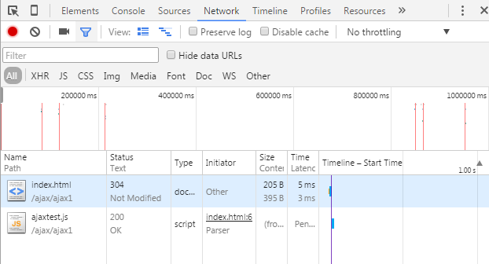

* 1. After you click on the link

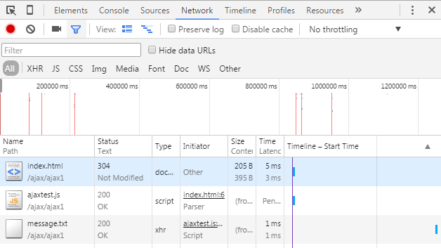

**Part 3**

1. Preview all files in the /ajax-html/ folder, including the html files in the /files/ folder.
2. Copy /ajax-html/ to ‘c:\xampp\htdocs’, then open ‘localhost/ajax-html/index.html’ in Chrome and test the links. The page should update with the appropriate links if everything is working properly:

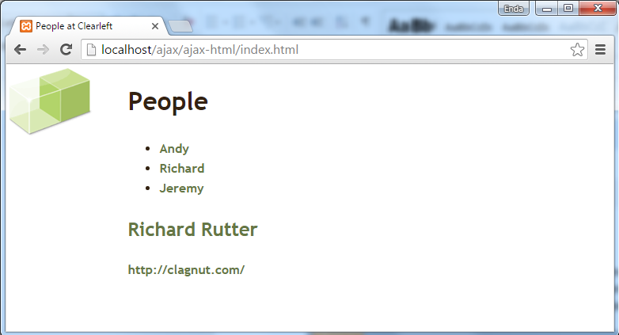

1. Using the web-inspector, view what’s happening at each stage in the communication

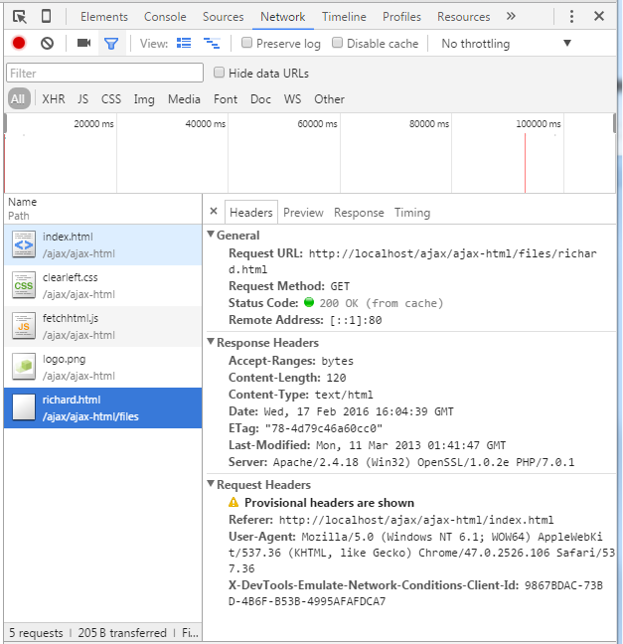

**Part 3**

1. Write an identical application to Part 2 that uses XML files for each person (Andy, Richard and Jeremy).

e.g.

<?xml version="1.0" encoding="utf-8"?>

<details>

<name>….</name>

<website>…</website>

<email>…</email>

</details>

1. Save the application in c:\xampp\htdocs\ajax-xml\
2. Use the notes to figure out how the JavaScript code will parse the information from the xml files.
3. Use DOM methods to create all the elements you need to add to the page (i.e. document.createElement(), document.createTextNode() etc.)

Note: You should ***not*** use the innerHTML property

**Part 4**

1. Write an identical application to Part 2 that uses JSON files for each person (Andy, Richard and Jeremy).

e.g.

{"person": {

"name":"Andy Budd",

"website":"http://andybudd.com/",

"email":"andy@clearleft.com"

}

}

Save the application in c:\xampp\htdocs\ajax-json\

1. Use the notes to figure out how the JavaScript code will parse the information from the JSON files.
2. In this part, use the innerHTML property (***not*** DOM methods) to add the data to the page